**DC MOTOR SPEED CONTROL**

Design the dc motor model with equations and control the speed and torque of the dc motor by varying the voltage.

**Requirements**

**High Level Requirements**

**To control the speed, torque of dc motor**

| **ID** | **DESCRIPTION** |
| --- | --- |
| HLR1 | To analyze circuit equation |
| HLR2 | To model the motor using analyzed equation |
| HLR3 | To control the speed torque of the motor |

**Low level Requirements**

| **ID** | **DESCRIPTION** |
| --- | --- |
| LLR1 | To understand electric circuit diagram and equation using basic components |
| LLR2 | To model the parameters in simulink and test the result |
| LLR3 | control parameter of motor using varying voltage |

**SWOT Analysis**

[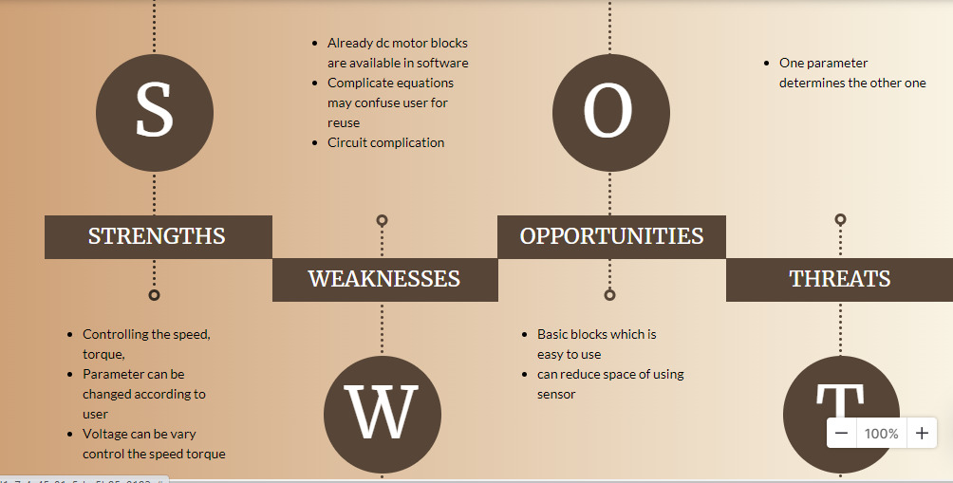](https://user-images.githubusercontent.com/89115879/160097410-1357c70b-a3b8-4579-b692-ef1964fbe303.PNG)

**4 w & 1H**

**What**

* To design a dc motor model

**Why**

* to control speed and torque by varying it's voltage.

**How**

* To solve the mathematical equation and model according to equation.

**When**

* It is used in the application whenever any dc motor controlled items required to control its speed torque

**where**

* In automobile and machinery which need dc motor

**Formula**

* Va = Raia + La +Kaфꙍ
* Kaфia = J + Bꙍ +T1
* Using these formulas, we get Torque and speed values which is later compared with the MATLAB simulation graph. Later we take a graph to see how the current is varying with the change in torque.

**Motor parameter**

Motor parameters with the parameters:

* Rated power = 2 kW Rated
* armature voltage = 125 V
* Rated armature current = 16
* A Rated speed = 1750
* Vrpm Ra = 0.24 Ω, La = 18 mH, Kaφ = 0.6699, J = 0.5 kgm2, Tl = 0.01 + 3.189× 10−4 × ω2 m.
* Obtain the speed and torque waveforms.

**Dc motor**

Modelled only for speed of the dc motor using some parameter[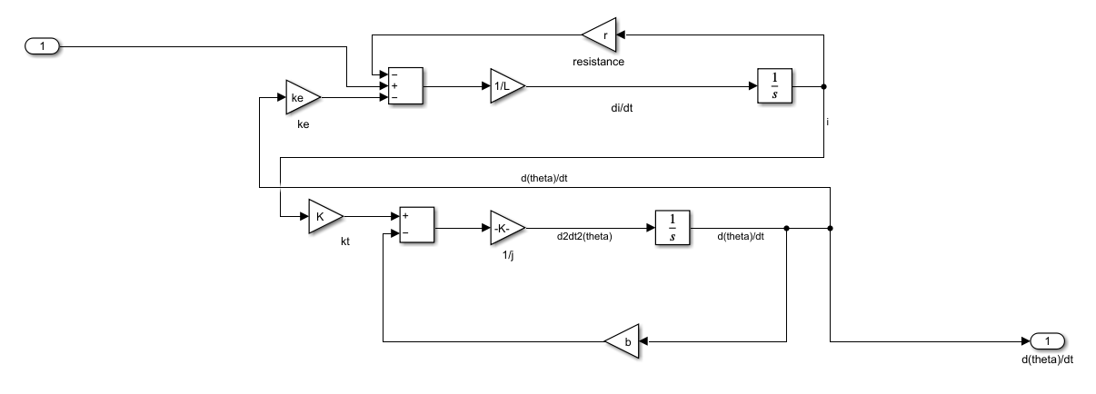](https://user-images.githubusercontent.com/89115879/160168952-3e6ccfa3-8923-4da0-9d21-db5642e508b1.PNG)

**Dc motor basic subsystem**

[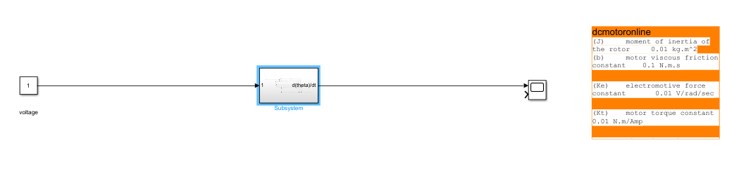](https://user-images.githubusercontent.com/89115879/160169092-9d853192-7e63-4b0b-82e2-3a2f03836121.PNG)

**waveform**

[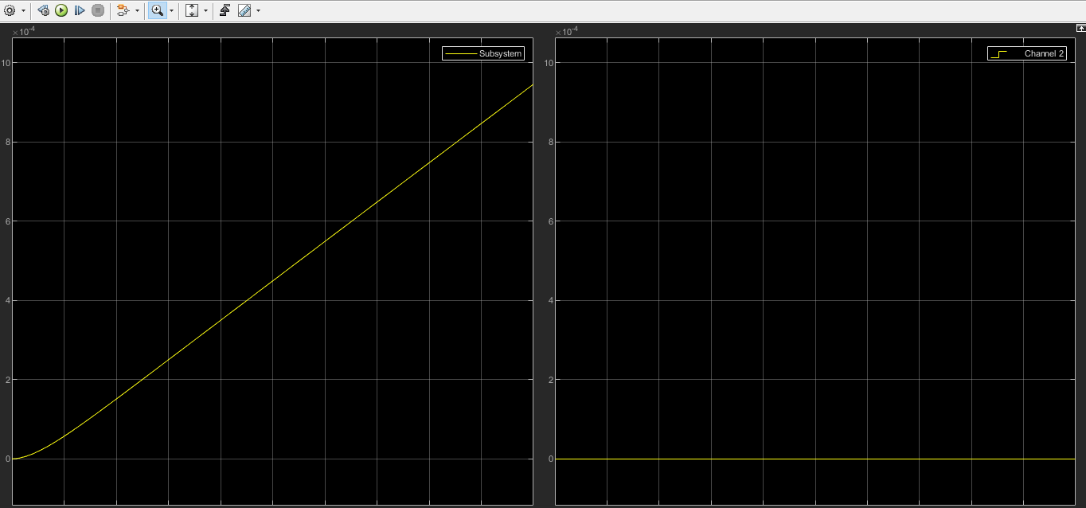](https://user-images.githubusercontent.com/89115879/160169131-d4200eb9-6a46-455d-9a68-2a2a29dfc0c6.PNG)

**version 2**

**dc motor modelled with some parameters taken and control both speed torque**

* simulation of dc motor

[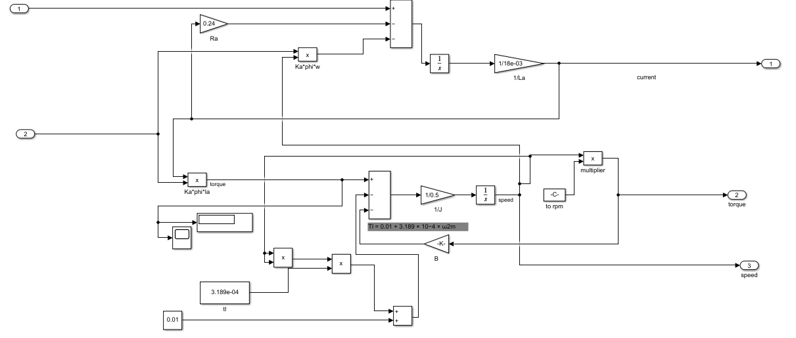](https://user-images.githubusercontent.com/89115879/160173366-20ff7490-2855-42aa-8fae-245f04cbb9bb.PNG)

**Subsystem of Dc motor**

[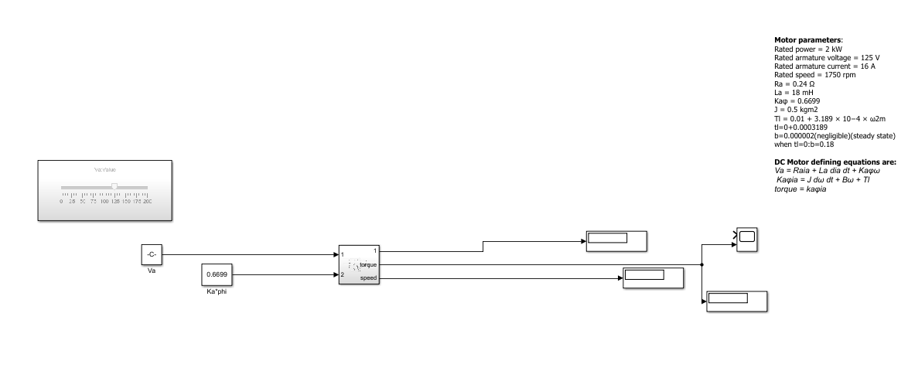](https://user-images.githubusercontent.com/89115879/160173430-002ff4bc-5122-4725-82e7-1a84829d0de2.PNG)

**Graph for speed and torque**

[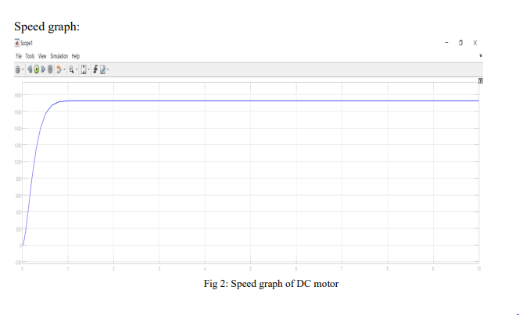](https://user-images.githubusercontent.com/89115879/160173901-77618374-1fcc-4904-a790-751a0e4254c6.PNG) [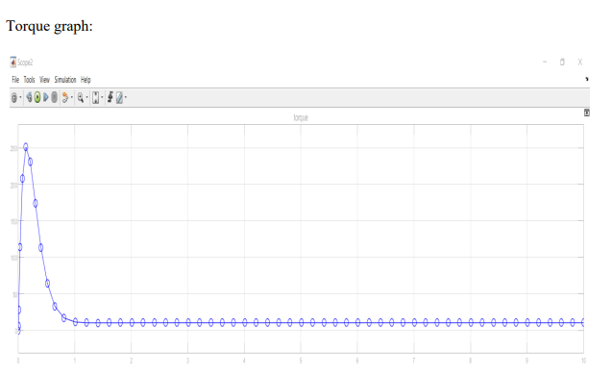](https://user-images.githubusercontent.com/89115879/160173589-cd500d4f-674e-47c8-8d06-5f700eddcbfd.PNG)